THE REPORT ON SANTHWANAM 2021
A SOCIAL OUTREACH TO PROVIDE SUPPORT TO DIFFERENTLY ABLED WOMEN

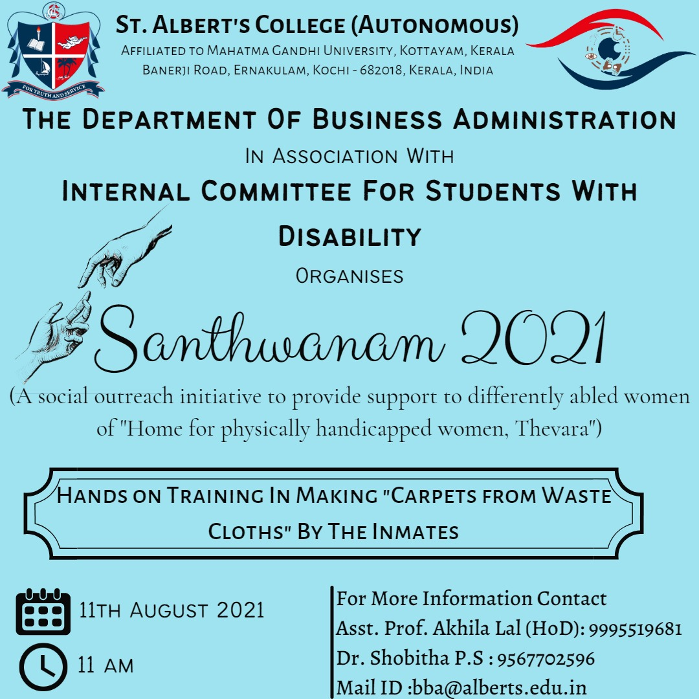

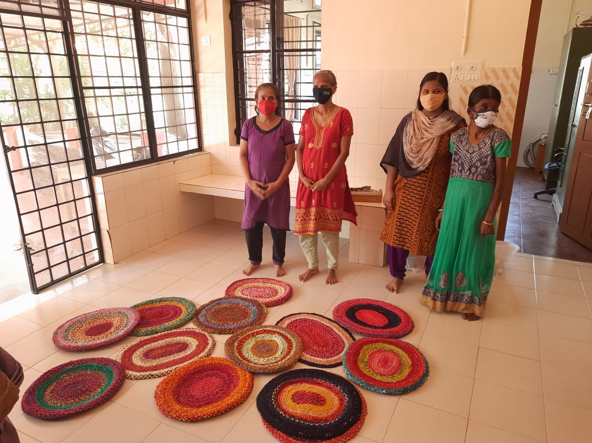
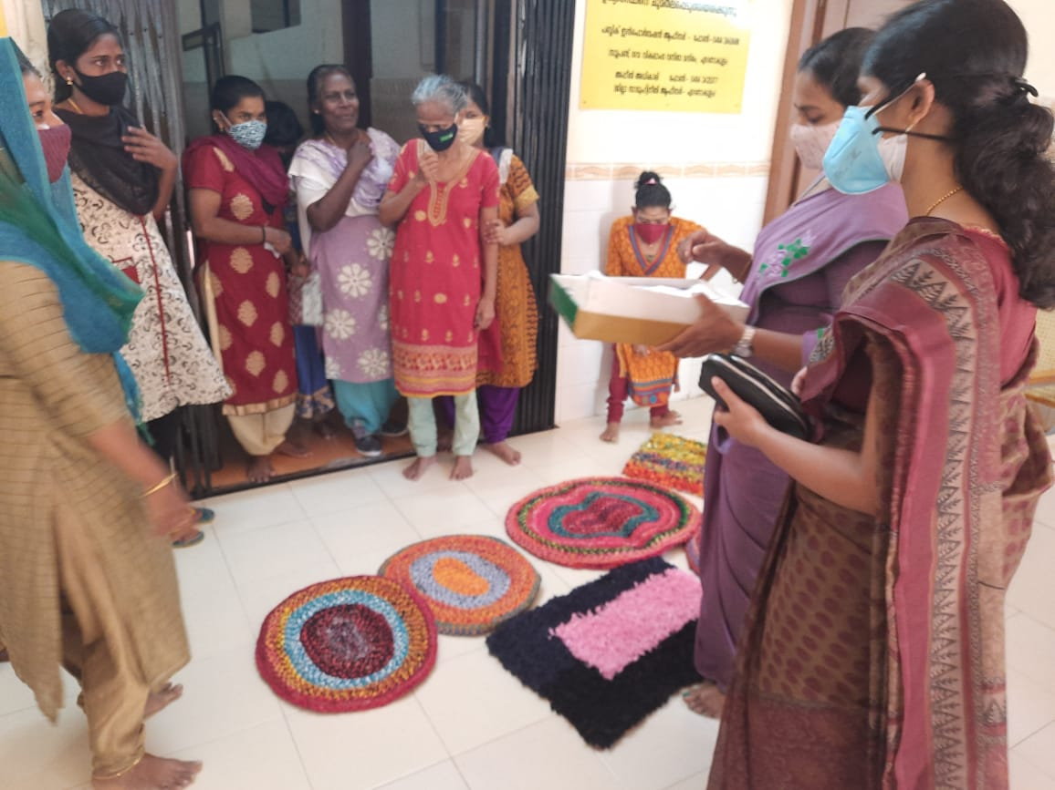
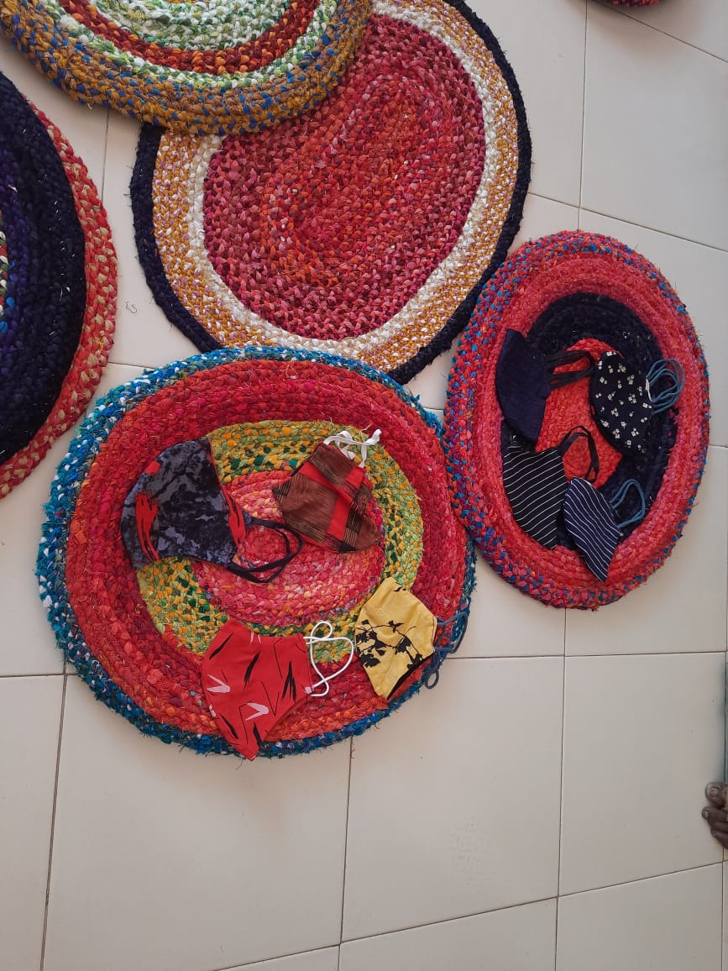
The Department of Business Administration, St. Albert’s college (Autonomous) in association with Internal committee for students with disability conducted Sathwanam 2021, A Social outreach initiative to provide support to differently abled women of “Home for physically handicapped women thevara and there by hands on training in making carpets from waste clothes by the inmates.

The program was conducted on 11th August 2021at 11am. The program was coordinated by Asst. Prof. Akhila Lal (HOD, BBA Dept.), Asst. Prof, Shobitha P S, Dr. Ajitha H, Asst. Prof. Serin Sajan and the students of 2nd and 3rd year of BBA. We visited the place and also distributed some useful items such as soaps, face mask and food items.
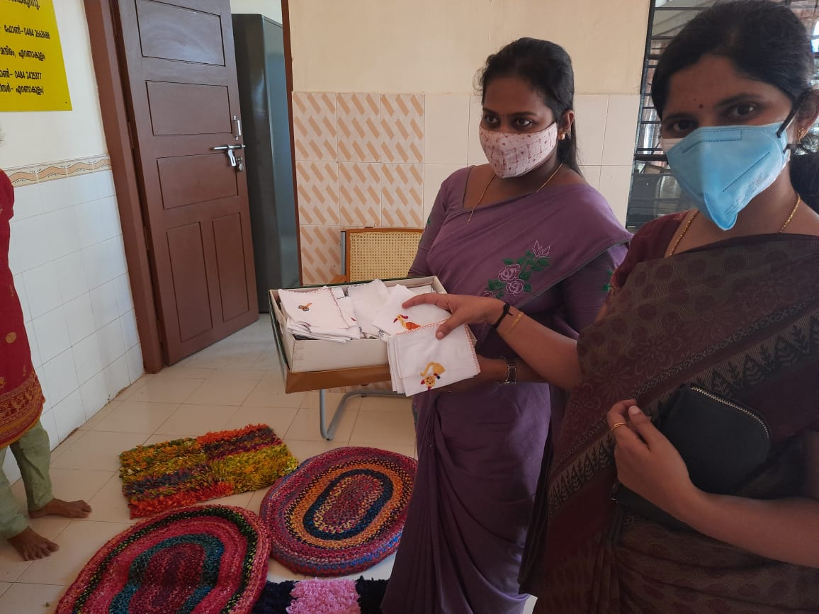
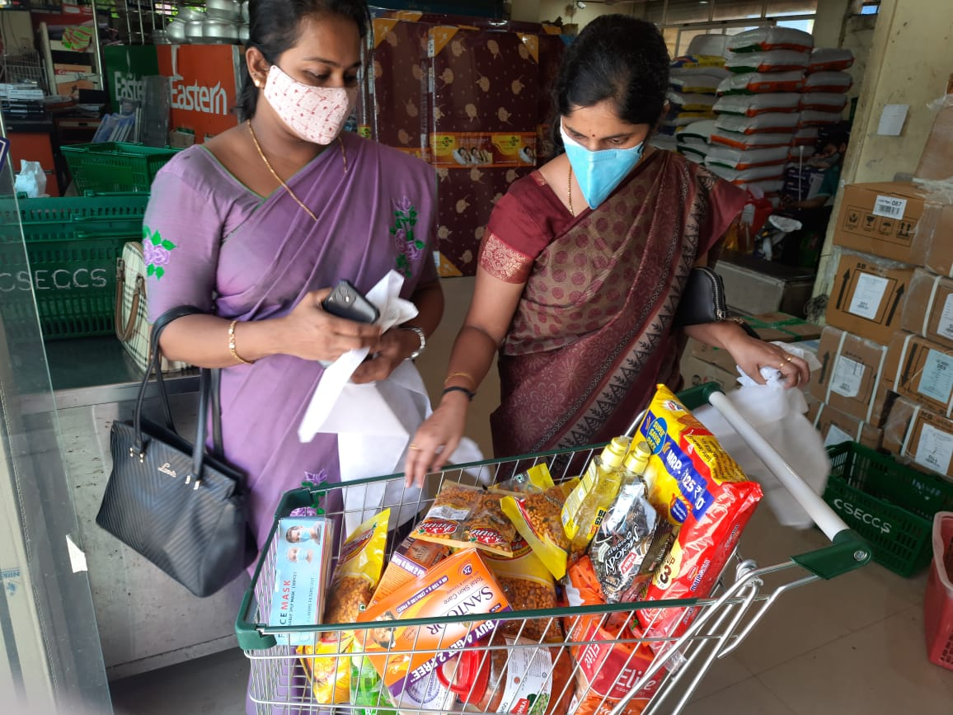

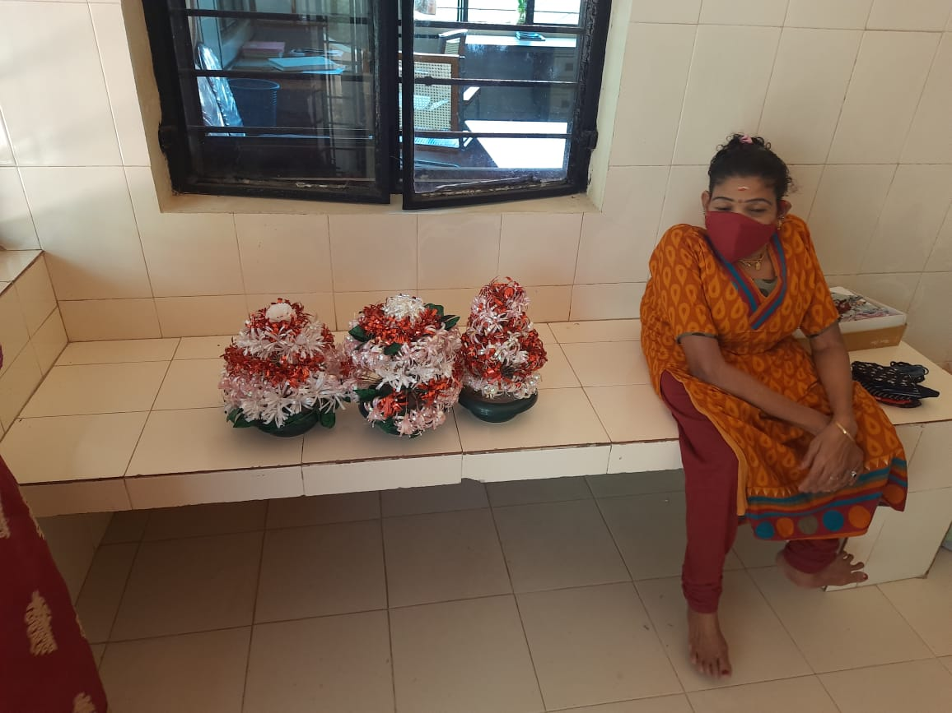
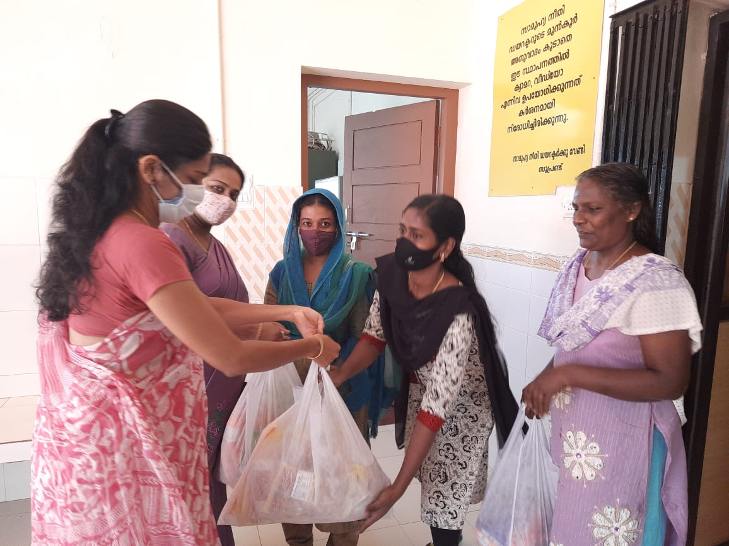

PARTICIPANTS DETAILS OF SECOND YEAR

Name. Phone Number Mail ID
Ajwin Johnson 9947099356 ajwinjohns007@gmail.com
Antony Amal K J 9447128751 amalantony256@gmail.com
Aman Agarwal 8848542682 amanagarwal2714@gmail.com
Angela joseph 6238809501 200606@student.alberts.edu.in
Cienna Babu 8943399988 ciennababu@gmail.com
Sneha Xavier 8848460077 snehaxavier0701@gmail.com
Joel Rony 9539650369 joelrony11@gmail.com
Roya Mariam Thomas 9847460215 royamariamthomas@gmail.com
Dhiya Varghese 7034050500 dhiyavarghese456@gmail.com
Dain Rocky 7510568785 dainrocky12@gmail.com
Sam Manoj Philip 9562173819 200613@students.alberts.edu.in
Ashin Jenson. 9633887241 ashinjenson2300@gmail.com
Sreeram U 9495093059 Sreeramunnikrishnan@gmail.com
Ardra Biju 7902599998 ardrabiju3k7@gmail.com
Abhishek R Nair 9995736736 abhishekrnairappooos@gmail.com
Nikhil Antony 8086239200 nikhilantony306@gmail.com
Esther Sereena Cyrus 9207211669 esthermosu@gmail.com
Rijas Jamal 9947506974 rijasjamal45@gmail.com
Vyshnav Unnikrishnan 8848629445 vaishnavunni171@gmail.com
M G Ayana 8590839288 ayanamg2001@gmail.com
Sreejith N Anand 9207377665 sreejithanand21@gmail.com
Calvin M Stalin 8078577519 calvin.m.stalin@gmail.com
Mohammed Imraan Akbar 6235201114 imraanakbar6@gmail.com
Mruthul Das 9544841587 mruthul003das@gmail.com
Aishwarya Sanjeev 8589042818 Aishwarya23.sanjeev@gmail.com
Mary Clodia Joseph 8129053523 maryclodiyaj@gmail.com
Younus Yousuf mb 8848045110 ymb6261@gmail.com

PARTICIPANTS DETAILS OF THIRD YEAR

Name. Phone number Mail id
Aditya N prabhu 9496690396 bba1601@student.alberts.edu.in
Drisya P 9072860862 bba1602@student.alberts.edu.in
Salman 9567385219 bba1603@student.alberts.edu.in
Lithin 8281007485 bba1605@student.alberts.edu.in
Aman Antony 974440907 bba1606@student.alberts.edu.in
Aisha Riyas 8086476000 bba1607@student.alberts.edu.in
Ashwin 8137056902 bba1608@student.alberts.edu.in
Alistair M Rozario 7736027335 bba1609@student.alberts.edu.in
Rahul 7306939375 bba1610@student.alberts.edu.in
Thejus 8078270380 bba1611@student.alberts.edu.in
Sanjeev 7356012315 bba1612@student.alberts.edu.in
Daral 8593966085 bba1614@student.alberts.edu.in
Aghi 8129335881 bba1615@student.alberts.edu.in
Fahim 8156921782 bba1616@student.alberts.edu.in
Lijin 9645725936 bba1617@student.alberts.edu.in
Anandhakrishnan 9947631328 bba1618@student.alberts.edu.in
Hridya. 7591937100 bba1619@student.alberts.edu.in
Mary varsha 9567807725 bba1620@student.alberts.edu.in
Niya 8086858524 bba1621@student.alberts.edu.in
Ashlin 9747318841 bba1622@student.alberts.edu.in
Eby 7034483749 bba1623@student.alberts.edu.in
Mary Tania 9946265693 bba1624@student.alberts.edu.in
Sandra 8921573702 bba1625@student.alberts.edu.in
Nasreen 9562051430 bba1626@student.alberts.edu.in
Aleena 7736452194 bba1627@student.alberts.edu.in
Arya 8590952902 bba1628@student.alberts.edu.in
Fiya 8137073097 bba1630@student.alberts.edu.in

