Report on Intercollegiate Slogan Competition

Conducted by “Internal Committee for Students with Disabilities”

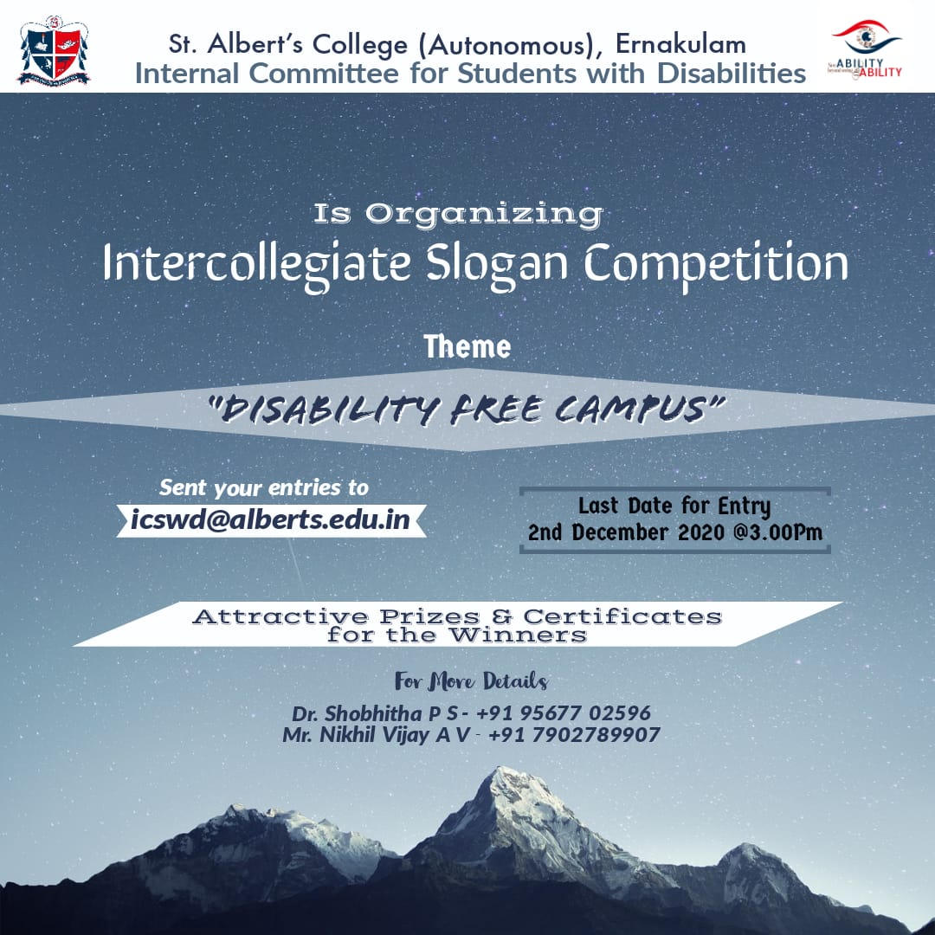

Date: 02/12/2020
Time: 3:00 PM
Student Coordinator: Nikhil Vijay
Teacher Coordinator: Dr. Shobita.P.S

Objective: Intercollegiate Slogan competition was conducted by “Internal Committee for students with disabilities” St. Albert’s College (Autonomous) for college students. There were 8 participants and the winners were awarded with E-Certificate and Cash Prize.

WINNERS:

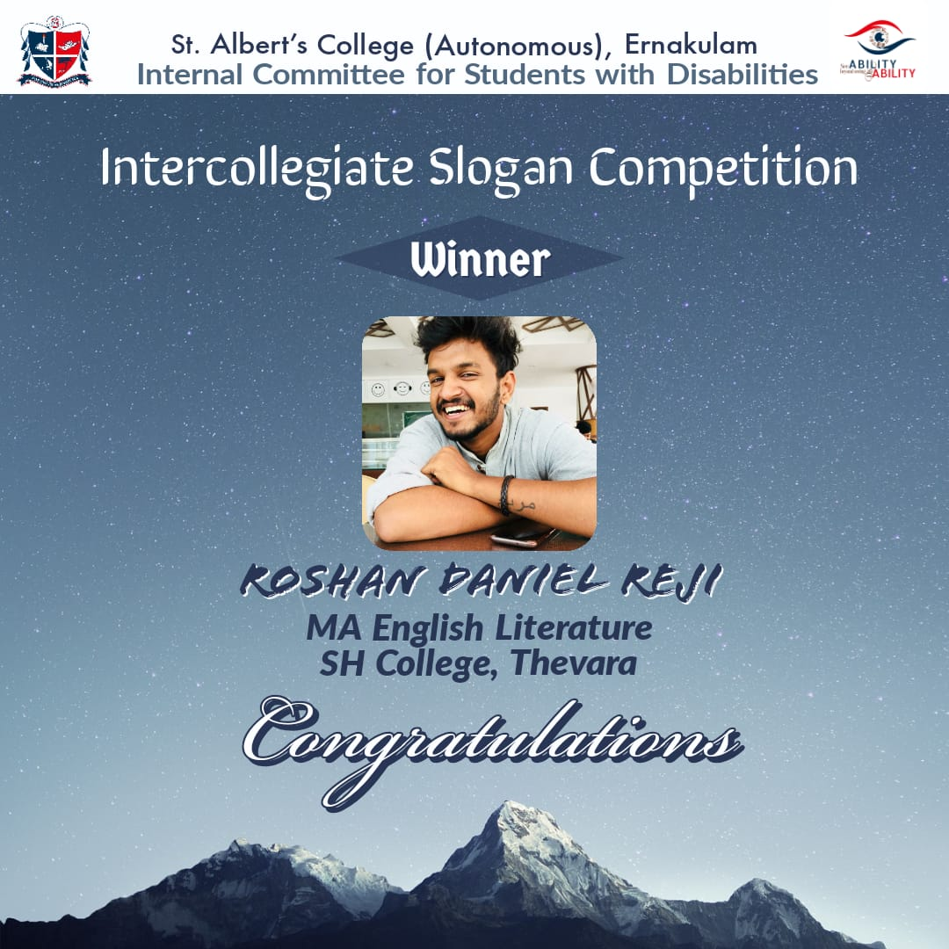

CERTIFICATE for WINNER

