Report on LOGO Designing Competition

Conducted by “Internal Committee for Students with Disabilities”

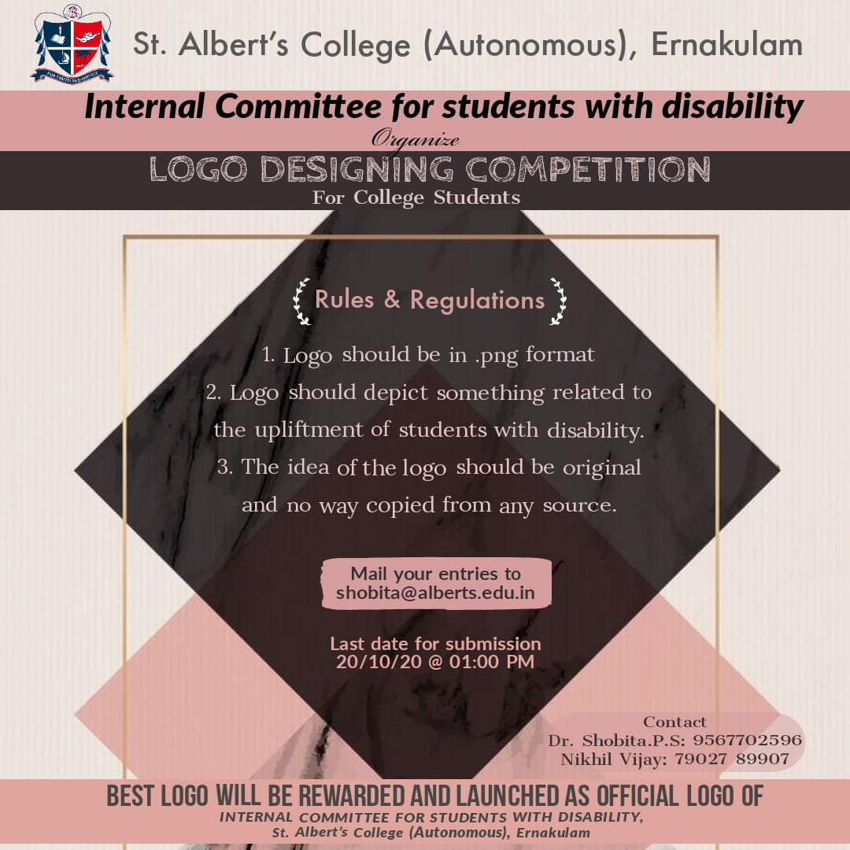

Date: 20/10/2020
Time: 1:00 PM
Student Coordinator: Nikhil Vijay
Teacher Coordinator: Dr. Shoboita.P.S

Objective: Logo Designing competition was conducted by “Internal Committee for students with disabilities” St. Albert’s College (Autonomous) for college students. There were 8 participants and the winners were awarded with E-Certificates. The logo for the cell was finalized.

WINNERS:

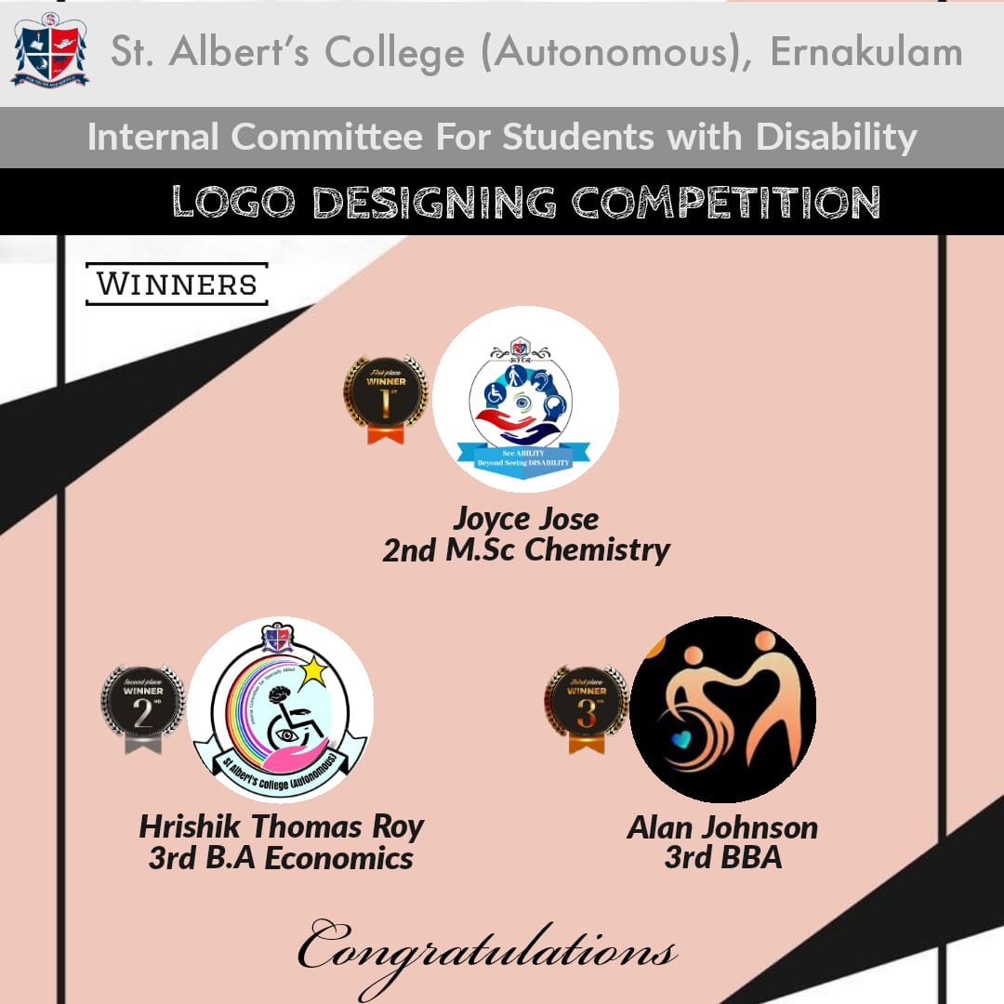

LOGO FOR THE COMMITTEE

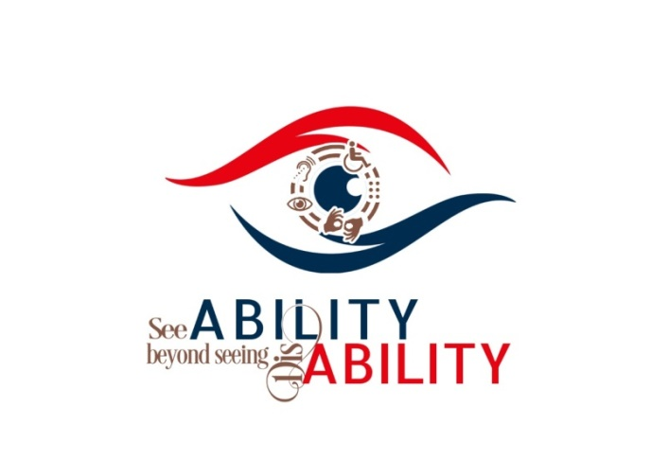
CERTIFICATE for WINNER

