Report on Webinar

A Mind without Fear-Meeting with ANJAN SATISH

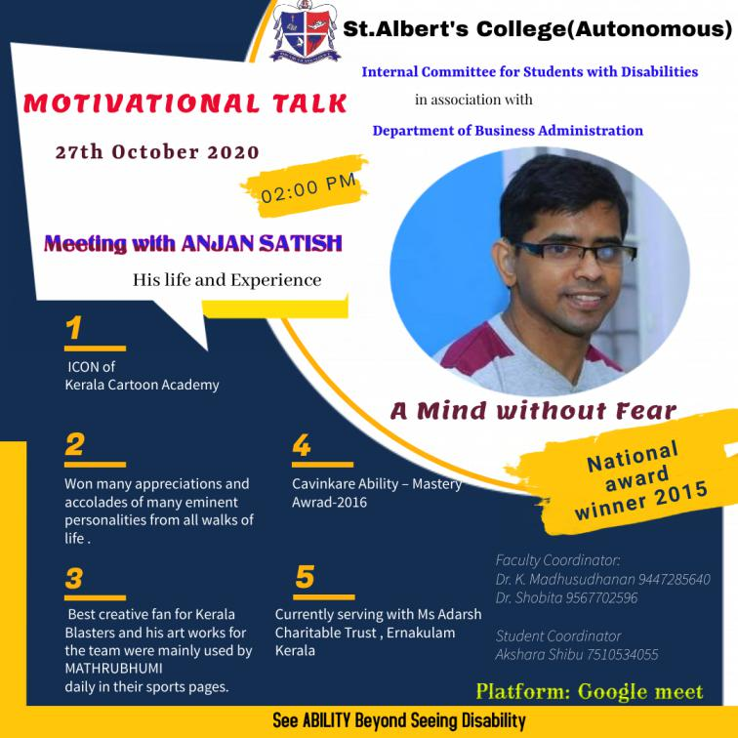

Date: 27.10.2020
Time: 2.00 -3.00
Student Convenor: Akshara Shibu
Prayer: Richa Joy
Welcome Note: Dr. Madhusudhanan Nair
Introductory Speech about the Speaker: Dhanya Manoj
Felicitation: Rev. Fr. John Vadassery
Vote of Thanks: Dr. Shobita.P.S

Objective: The objective of the webinars served to iidentify policy gaps and challenges in addressing the acute and longer-term needs of persons with disabilities, design and implement policy solutions to protect and empower persons with disabilities.

Target audience:

Children with Disabilities
NGOs and National Policy makers of Disable Person
Students and Faculty of Colleges

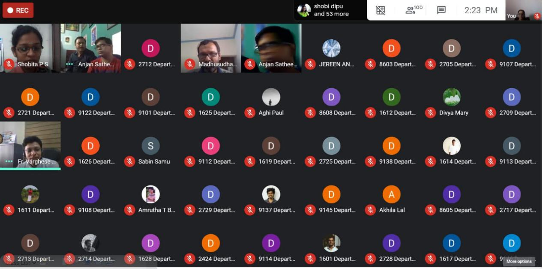

Introduction:
In the run-up to the Live webinar Internal Committee for students with disabilities in association with Department of Business Administration has taken up an initiative to motivate children with disabilities.Children with disabilities are more often exposed to unssupportive environments, adding to their vulnerability and limiting their opportunities to learn and participate in meaningful ways. Today, disability is no longer conceptualized as a consequence of a disease, but is understood as a dynamic interaction between a person’s health condition, environmental factors and personal factors (no longer a linear, but interactive model).The right to health is enshrined in the UN Convention on the Rights of Persons with Disabilities. However, there are a range of barriers and issues that people with disability may experience with the health system that contribute to poorer outcomes for people with developmental disabilities. A lack of coordination between the National Disability Insurance Scheme (NDIS) and health systems can compound the issues experienced by persons with disabilities. In this scenario, the responsibilities lie up on us pay the attention through a webinar in the form a talented national icon who can able to forecast the future of fellow beings by saying them as not weak but brave to fight for themselves.

Overview and Takeaways:

The webinar was structured in an introduction with documentary of Anjan Sathish and was attended by 95 participants plus 5 hosts members.In the presentation he has showed his paintings and achievements; Icon of Kerala Cartoon Academy, Best creative art works for the Kerala Blasters football team, Cavinkare Ability- Maestro Award 2016 and many more. The presentation demonstrates how innovative approaches can and are already contributing to the objectives of the webinar, illustrated by the example of painting skills, and motivational speech of his parent. This webinar aggravate the experiences of disability into ability and it wipe out the concept of pparticipation restrictions of children with disabilities which has long been seen as direct consequences of disorders and impairments.Disability is understood as a multidimensional phenomenon, with disability and functioning marking the ends of a continuum of human functioning that becomes visible in the involvement in life situations. It is the result of complex interactions between the person and the environment.An Iinclusive education for such person need to be done in mandatory in every aspects of learning through creating enabling environments in institutions.

Conclusion:

The ccompendium is a living document of a child having Cerebral Palsy from early ages of life. To break such vicious circles requires an understanding of disability which can map the interactions between characteristics of the person and the environment. This report presents a summary of the presentations and evaluates the discussions and feedback from participants collected through email and chat box.

List of Registered Participants

Name | Email | Mobile No
Aysha Rinas | aysharinas786@gmail.com | 8086476000
Sulthan Sabeer | sulthan.sabeer22@gmail.com | 6282781542
Ananthakrishna murali | ananthakrishnab4@gmail.com | 9846784958
Anju Mathew | anjumathew3121@gmail.com | 9539490751
SREEDURGA A K | bbot9129@student.alberts.edu.in | 7510118735
JEREEN ANN THOMAS | jereensce@gmail.com | 9562024170
Jesna Abdul Jabbar | jesnajabbar007@gmail.com | 9995519967
Abal biju | abalbale011@gmail.com | 7592940339
Salman fariz.s | bba1604@student.alberts.edu.in | 9567385219
SHERIN E S | sherinsa18@gmail.com | 7356756044
Neema | bbot9142@student.alberts.edu.in | 7736266099
Devika AU | devikaddd123@gmail.com | 9562955420
Annie Jenet Jacob | jenetjacob27@gmail.com | 8089512326
Fathima safa | bbot9125@student.alberts.edu.in | 7994935479
ANANDHAKRISHNAN | anandhukrizz321@gmail.com | 9947631368
Andriya C A | bbot9139@student.alberts.edu | 7025808528
Aleena kl | aleenakl102@gmail.com | 7510396432
Rahul Jenin | rahuljenin@gmail.com | 9562332214
Anjitha treesa | anjithatreesa1999@gmail.com | 9847794242
Oliena Jose | bbot9128@student.alberts.edu.in | 7356163500
ABHIRAMI K S | abhiramiks889@gmail.com | 7994383159
Hridhya Sudharsanan | bba1619@student.alberts.edu.in | 7591936100
A.M.GAYATHRI | kumarkrish1100@gmail.com | 6282351819
A.M.GAYATHRI | kumarkrish1100@gmail.com | 6282351819
Aghi paul | aghipaul2001@gmail.com | 8129335881
Ashlin Roy | ashlinroy12@gmail.com | 9747318841
Mary Tania Simenthy | tnias2001@gmail.com | 9946265693
Christy Francis | christygeorgechirackal23@gmail.com | 9946198430
Eby joseph P.J | ebyjoseph90@gmail.com | 7034483749
VISHNU V. S | vishnuvsabu2000@gmail.com | 9847174073
VISHNU V. S | vishnuvsabu2000@gmail.com | 9847174073
Fezin ps | bba2706@student.alberts.edu.in | 8129175599
Nithya S Menon | nithyamenon89@gmail.com | 9447371550
Denil alex | denilsanfransisco@gmail.com | 8281088113
Ashin Paul kd | bbot9144@student.alberts.edu.in | 9567281434
Levin George | levingeorge007@gmail.com | 9.18848E+11
Elgeyo Dominic Mendez | elgeyomendez2000@gmail.com | 7356639704
Jefrin Edward | jefrinedward15@gmail.com | 8129884131
Joice Joy | joicejoy06@gmail.com | 9446684063
Arpana Jayan | arpanajayanammu@gmail.com | 8078719830
Gouri M M | bbot9104@student.alberts.edu.in | 8848618379
Jeena kunjumon | bbot9135@student.alberts.edu.in | 9400281780
Sherin Joseph | sherin.justin2000@gmail.com | 9072481417
Gopikagopi | bbot9103@student.alberts.edu.in | 9562677063
Joshna Antony Aruja | bbot9143@student.alberts.edu.in | 7994793627
Lidiya k.s | bbot9105@student.alberts.edu.in | 7994933506
Josemary Ashmy | bbot9111@student.alberts.edu.in | 8330063616
Ann Merin | bbot9112@student.alberts.edu.in | 7593960779
Shara Twinkle | sharatwinkle5@gmail.com | 8138087422
FATHIMA NESNIN M A | nesninfathima03@gmail.com | 7558027992
Shara Twinkle | sharatwinkle5@gmail.com | 8138087422
Silpa k s | bbot9145@student.alberts.edu.in | 9446386029
Aparna A N | bbot9110@student.alberts.edu.in | 9526724117
Kavya R | bbot9122@student.alberts.edu.in | 6238789091
Kavitha N | bablukavi99@gmail.com | 9567742132
Egna kt | bbot9114@student.alberts.edu.in | 9074947954
Mariya Laya | bbot9101@student.alberts.edu.in | 7592043660
A V Vivek | bbot9130@student.alberts.edu.in | 7907512682
Ashwin J Raj | bbot9108@student.alberts.edu.in | 9495959215
SHERIN E S | sherinsa18@gmail.com | 7356756044
MARGRET NEENA | neenamarg@gmail.com | 6235203932
Farheen A | sajithaabid11@gmail.com | 8129371333
Albert P Varghese | bbot9137@student.alberts.edu.in | 9400794967
Pravitha Pradeep | mbot8608@student.alberts.edu.in | 9495947517
Drisya P | drisya_p@outlook.com | 9072860962
Fahim Jabbar | fahimfahi080@gmail.com | 8156921782
Febin Francis | febinfrancis2000@gmail.com | 9746485241
Alweena Philcy T.J | alweenaphilcy72@gmail.com | 8129214267
Alistair M. Rozario | alistairrozario123@gmail.com | 7736027335
Daral sabu | daralsabu8281@gmail.com | 8593966085
Niya P Wilson | niyapwilson@gmail.com | 8086858524
Aashwin Antony.T | aashwinantony176@gmail.com | 8137056902
Sanjeev Yadav | sanjeevyadav735601@gmail.com | 7356012315
Ligin jose paul | liginjosepaul32178@gmail.com | 9645725936
Arya sunil | bba1628@student.alberts.edu.in | 8590952902
Aman Antony Augustin | bba1606@student.alberts.edu.in | 9744240907
JESNA PAUL | jesnapaul200@gmail.com | 9995048609
Jaison Dhas | jaisondevaraj@gmail.com | 9746156246
Vishnu Prasad | vishnuprasadbba2@gmail.com | 9846636870
ALFRED THOMSON K J | alfyalfredthomson@gmail.com | 8943159889
Ardhra C .R | ardhraanu21700@gmail.com | 9656288007
Nileena Rose Mary | nileenarosemary@gmail.com | 9746582683
Divyadarshana Anand | divyaanand71@gmail.com | 9656452342
Ashna Alex | ashnaalex732@gmail.com | 7306113566
Lima Babu | limababu163@gmail.com | 9847160732
Varsha Das | varrsha222@gmail.com | 7510818801
Jwala T | jwalat689@gmail.com | 9188414657
Nimmi Jospeh | nimmijoseff@gmail.com | 6282536904
Joseph Jean | jeanjoseph2709@gmail.com | 9947775806
Akshara Shibu | bba2712@student.alberts.edu.in | 7510534055
Sheron Williams | williamssheron2000@gmail.com | 8921467515
Sandra manoj | sandramanoj2382@gmail.com | 8592844693
Arya sunil | bba1628@student.alberts.edu.in | 8590952902
Sanjeev Yadav | sanjeevyadav735601@gmail.com | 7356012315
Nasreen V. A | nasreennechru@gmail.com | 9562051430
Adithya.N.Prabhu | adithyanprabhu368@gmail.com | 9496690396
Aleena Pious | bba1627@students.alberts.edu | 7736452194
Riya Joseph | csc7707@student.alberts.edu.in | 6282012242
Riya Joseph | csc7707@student.alberts.edu.in | 6282012242
Mary Varsha | bba1620@student.alberts.edu.in | 9567807725
Shobana Thomas | shobanathomas@stphilos.ac.in | 9880776047
Anna Jose | annajose1029@gmail.com | 9745893676
JEENIA C J | jeeniajohnson3@gmail.com | 7510252256
Lincy. V | lincyvarghese20010@gmail.com | 8590980230
Elizabeth Varghese Anthikkat | elizabethvargheseanthikkat@gmail.com | 8281901477
Alinja M Jehouse | alina.jehouse@gmail.com | 9744554653
Meenu Nixon | meenunixon123@gmail.com | 9495507983
Alan Johnson P.J | alanjohnsonmaalik@gmail.com | 7994964688
Anju George | anjupanamkutty@gmail.com | 9496506584
Shilpa jose | shilpajose2017@gmail.com | 9495428080
Elgeyo Dominic Mendez | elgeyomendez2000@gmail.com | 7356639704
Alen Joseph | alenjoseohkj123@gmail.com | 9846780929
Ziya Fathima Nassar | bba2724@student.alberts.edu.in | 7558043202
Dhanya Mathew | dhanyamathew500@gmail.com | 8113077198
Jaison Dhas | jaisondevaraj@gmail.com | 9746156246
JOEMOL P G | joemolpg99@gmail.com | 8304952476
Fahad ali | psmsaedali@gmail.com | 8943004500
Lhea Blue | lheablue044@gmail.com | 9895579856
Minsha Nazar | minshasanoob@gmail.com | 9995964609
Shahanas K.B | shahanas1176@gmail.com | 7907468439
Arpana Jayan | arpanajayanammu@gmail.com | 8078719830
Shahanas K.B | shahanas1176@gmail.com | 7997468439
Joseph lidwin lopez | lidwinlidu01@gmail.com | 8943045938
Pravitha Pradeep | mbot8608@student.alberts.edu.in | 9495947517
Pravitha Pradeep | mbot8608@student.alberts.edu.in | 9495947517
Mary Sruthy VJ | marysruthy1995@gmail.com | 8075693910
Anjal Shalet | anjalshalet2004@gmail.com | 9947729808
Rahul P S | rahulps1000@gmail.com | 9.18548E+11
Bibiya paul | bibiya0015@gmail.com | 8136873812
Jithu Paul Jacob | jithupaul@alberts.edu.in | 9605820182
Drisya P | drisya_p@outlook.com | 9072860962
Manu Martin | manumartin858@gmail.com | 8089248001
Nasreen V. A | nasreennechru@gmail.com | 9562051430
Maria Sandra Salas | bba1625@student.alberts.edu.in | 8921573702
RONCY KJ | roncykj2001@gmail.com | 7559943033
Lavina Wilson | lavinawilson1999@gmail.com | 9746463637
Nivedh Eustace | nivedh@alberts.edu.in | 9.17034E+11
Antony Lithin | antonylithin01@gmail.com | 8075916106
Richa Joy | bba2705@student.alberts.edu.in | 9061393441
Alan Johnson P.J | alanjohnsonmaalik@gmail.com | 7994964688
Abal biju | abalbale011@gmail.com | 7592940339
Levin George | levingeorge007@gmail.com | 9.18848E+11
Sanju Augustin | sanjuaugustin@alberts.edu.in | 7994040650
Roshan K R | kr18cr7@gmail.com | 8136992624
Sabin.C.S | sabincsamu@gmail.com | 9061978528

