Report on Webinar

INTERNATIONAL DAY OF DISABILITY

A talk on Give ear to Hearing

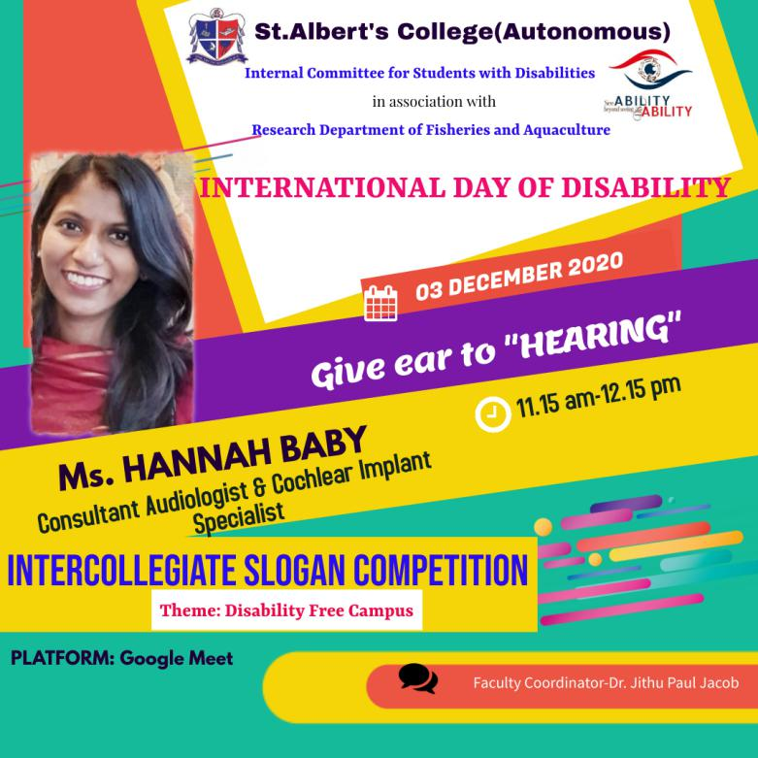

Slogan Competition
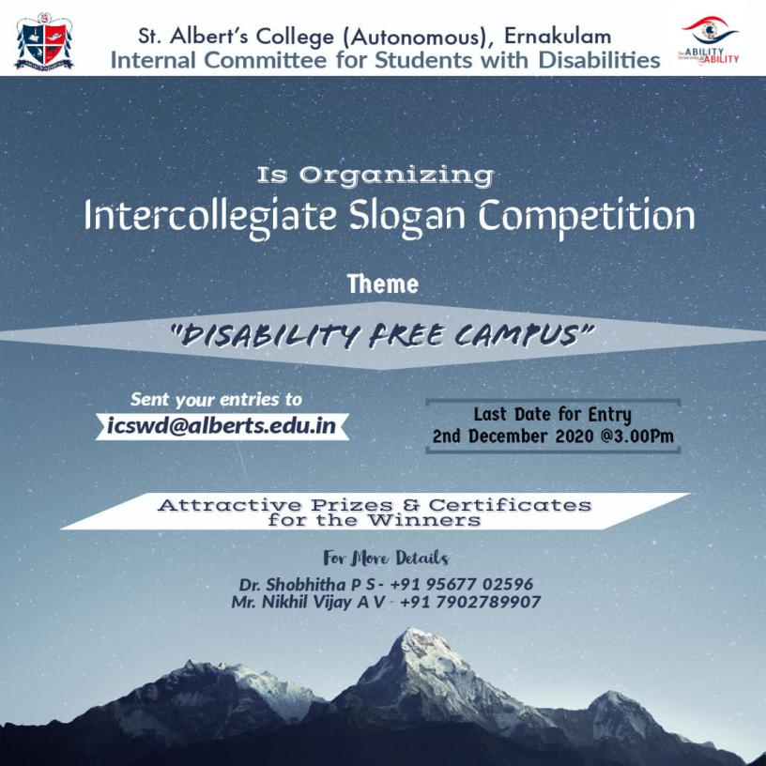

Date : 03.12.2020
Time : 11.15 -12.15
Student Convenor: Sruthi Vijay
Introductory Speech about the Speaker: Catherine Mary
Felicitation : Rev. Fr. John Vadassery
Vote of Thanks : Sreelakshmi Kamath

Objective : The objective of the webinar is to achieve the goal for inclusive strategy of students with disability which can be achieved through active consultation with persons and their representative organization.

Target audience:

Children with Disabilities
NGOs and National Policy makers of Disable Person
Students and Faculty of Colleges

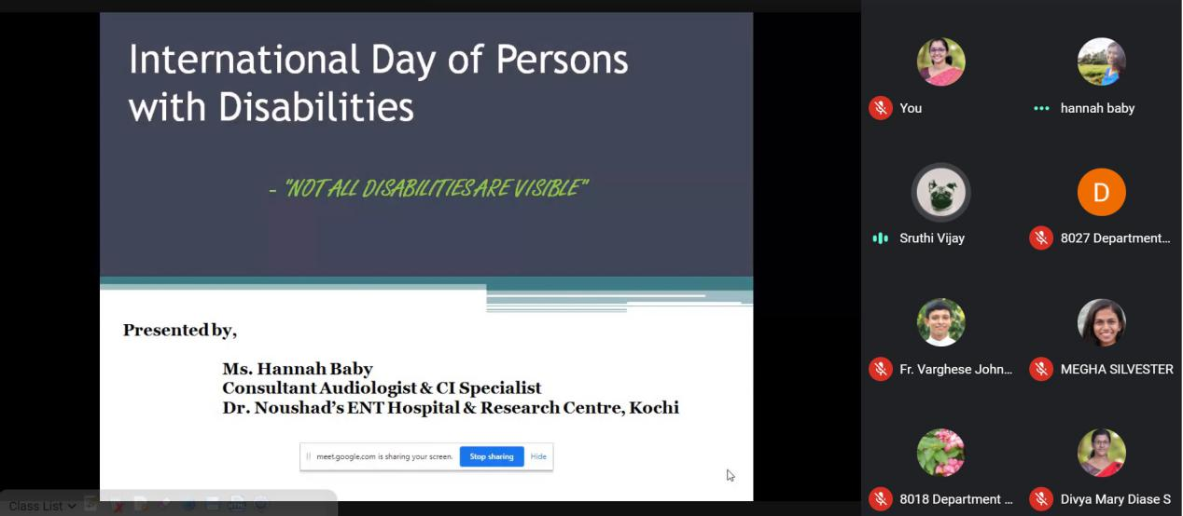

Introduction:
In the run-up to the Live webinar Internal Committee for students with disablities in association with Research Department of Fisheries and Aquaculture has taken up an initiative to celebrate the World International Day for Disability on Dec 03 . UNESCO has marked the International Day of Persons with Disabilities with a week-long programme from 25 November to 3 December 2020 under the theme: "Building back better: towards an inclusive, accessible and sustainable post COVID-19 world by, for and with persons with disabilities". Disability Inclusion Strategy will provide the foundation for sustainable and trans formative progress on disability inclusion through all pillars of the work and our college is also doing its part to maintain a disable free campus. However, there are many constraints to solve in an institutional level of understanding, these types of programme would level the target through social outreach reforms. Against this background, the back up attention seeking of any disable can succeed through cognizance programme like webinar is inevitable.

Overview and Takeaways:

The webinar was structured in an organized manner begin with prayer (Megha and Midhu) and felicitated by Rev. Fr. John Christopher Vadaserry. The speaker of the day Mrs. Hannah Baby had gave an elaborate lecturing on hearing impairment and associated post lingual deafness restructuring. The importance of infant assessment is very necessary for identifying any deafness, she added. The webinar was attended by 45 participants plus 5 hosts members. Along with the webinar the winner of slogan competition was also announced. There are several entry from various collage and were scrutinized by a panel of committee and it was declared among the best for the slogan “The only disability in the world is the inability to be inclusive”. Roshan Daniel, M A Literature, SH Collage, Thevara was the man behind this slogan. The webinar was effective in mean of giving awareness of inclusive strategy in all the sector of social life and institutional level.

Conclusion:

This webinar and slogan competition pay the occasions to educate the public on issues of concern, to mobilize political will and resources to address global problems, and to celebrate and reinforce achievements of humanity in a perspective of inclusive policy for disable.This report presents a summary of the presentations and evaluates the discussions and feedback from participants collected through email and chat box.

LIST OF PARTICIPANTS
Name | Name of the Institution with Place | Department | Email | Mobile No
Febin Francis | St Albert's College  Ernakulam | BBA | febinfrancis2000@gmail.com | 9746485241
Swapna C Senan | Sree Gokulam Medical College | Microbiology | swapnacsenan@gmail.com | 9895128455
Alan Johnson P.J | St alberts college Ernakulam | BBA | alanjohnsonmaalik@gmail.com | 7994964688
Lavina Wilson | St. Alberts college, Ernakulam | BBA | lavinawilson1999@gmail.com | 9746463637
Alina m jehouse | St Albert's College, Ernakulam | BBA | alina.jehouse@gmail.com | 9744554653
Jwala T | St Alberts college Autonomous Ernakulam | BBA | jwalat689@gmail.com | 9188414657
Midhu Silvester | St Albert's college autonomous Ernakulam | Department of fisheries and aquaculture | midhumegha16@gmail.com | 9746569277
Megha Silvester | St Albert's college autonomous Ernakulam | Department of fisheries and aquaculture | meghasilvester18@gmail.com | 9746569277
Athira Binduraj | St.Alberts College (Autonomous), Ernakulam, | BSc Industrial Fish and Fisheries | athirabinduraj05@gmail.com | 9074615298
Anju Antony | St Alberts College (Autonomous) Ernakulam | Department of Fisheries and Aquaculture | anjuantony223@gmail.com | 7902371815
Ananthakrishna murali | St Albert's college | Renewable energy | ananthakrishnab4@gmail.com | 9946784958
Shone joseph leons | St alberts college ernakulam | B.voc renewable energy | shonejosephleons@gmail.com | 8921474808
Pearl Antonette Mendez | St. Albert's College(Autonomous), Ernakulam | Renewable Energy | pearl@alberts.edu.in | 9497633729
Jefrin Edward | St Alberts college ernakulam | Bvoc renewable energy | jefrinedward15@gmail.con | 8129884131
Swapna C Senan | Sree Gokulam Medical College | Microbiology | swapnacsenan@gmail.com | 9895128455

