UG 2018 BATCH B.Sc. AQUACULTURE
N  o | Coordinator/ Area | N  o | Student Coordinator | Official Email ID | Mobile
1 | Secretary  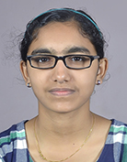 | 1 | Aparna Das A M | baqu9019@student.alberts.edu.in | 9495714148
 | (to be elected)  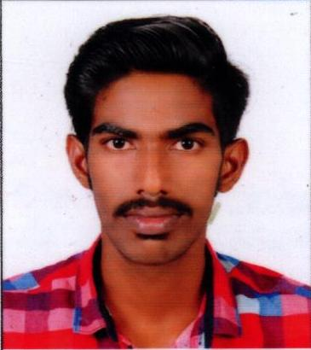 | 2 | Jackson Joseph
2 | DQAC  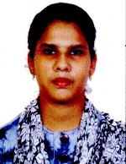 | 1 | Ancy Joseph | baqu9004@student.alberts.edu.in | 9567199551
 | 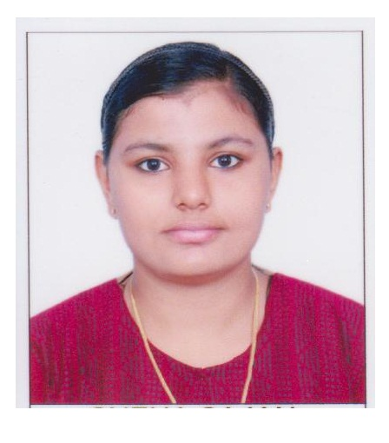 | 2 | Sneha Sajan | baqu9029@student.alberts.edu.in | 9746015744
3 | Treasurer  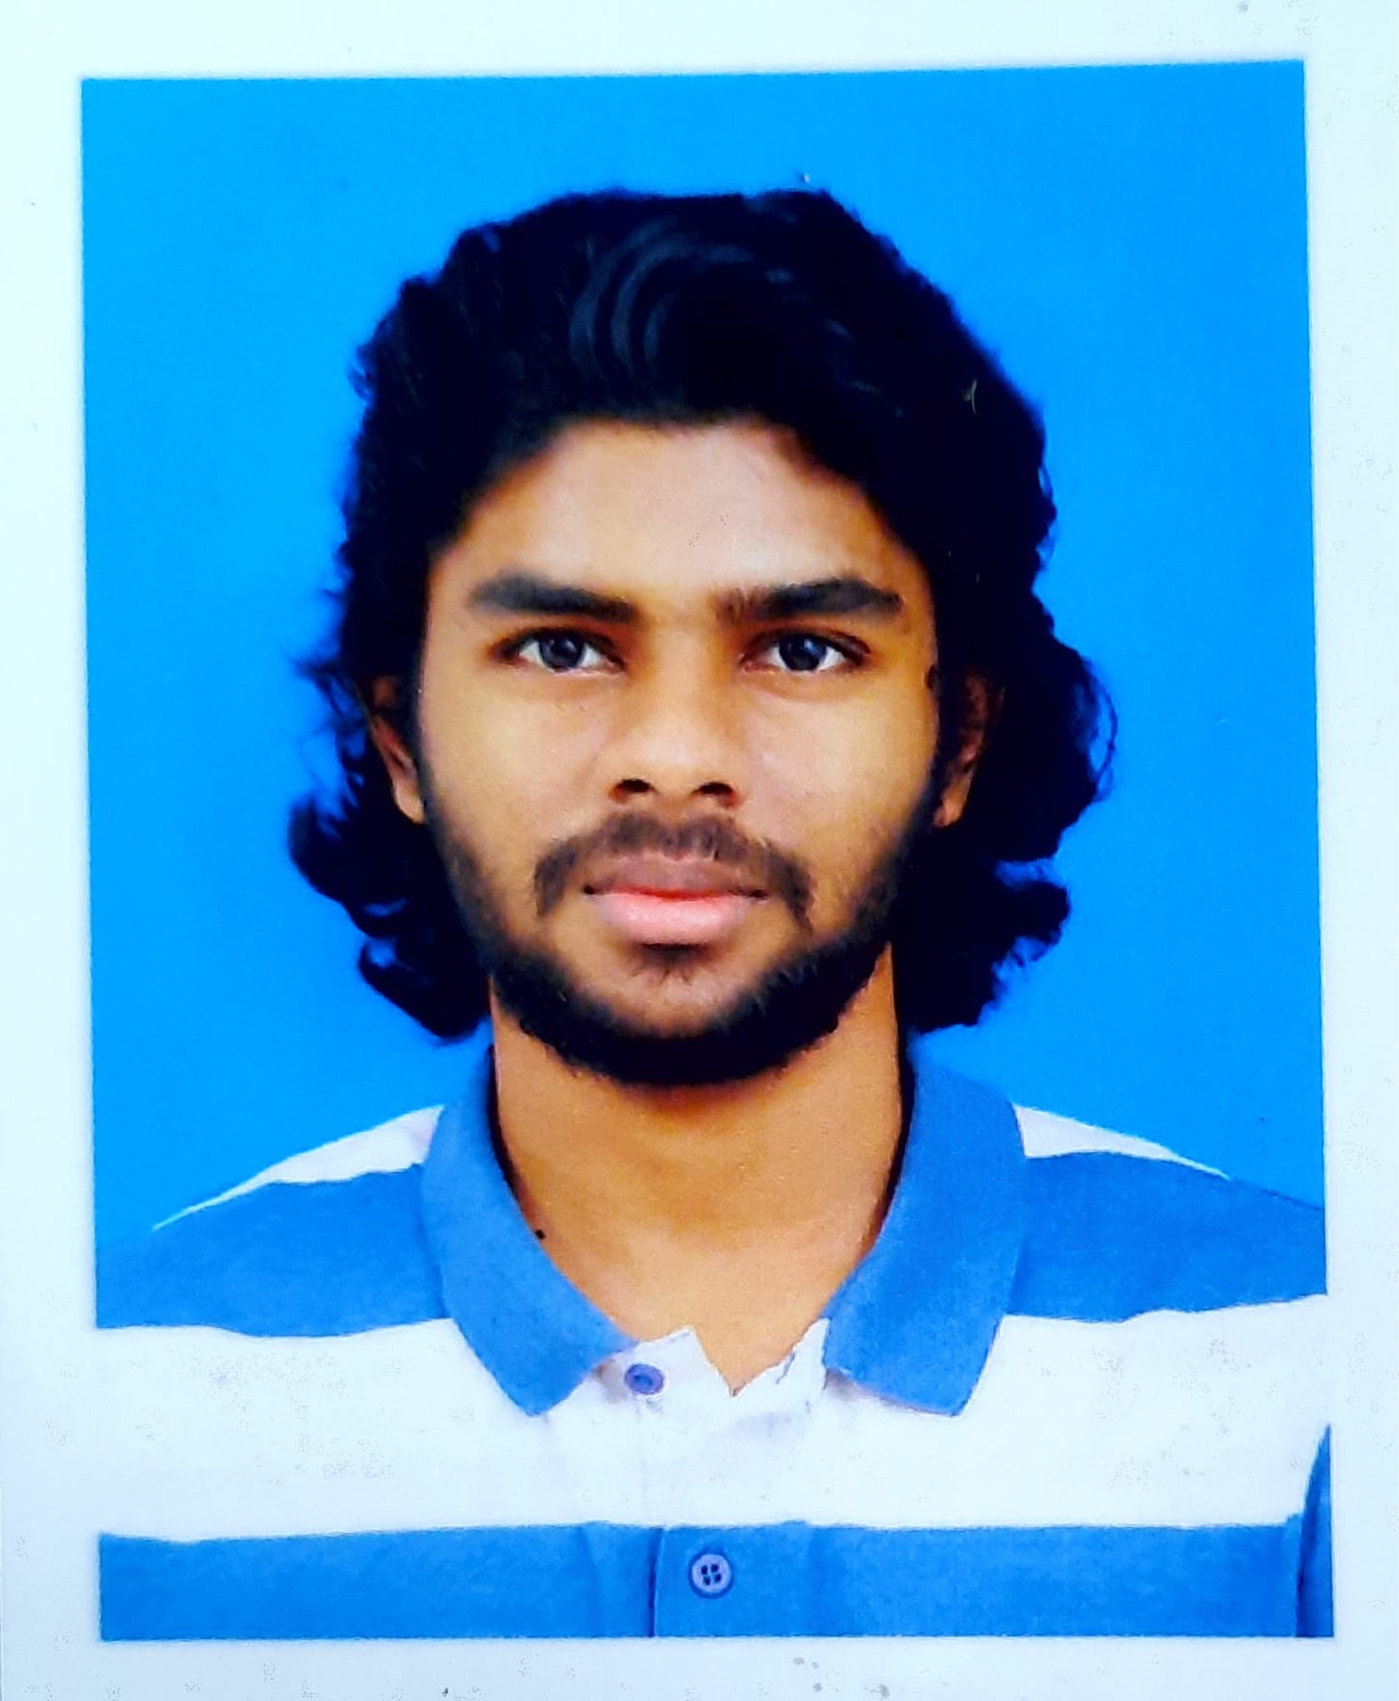 | 1 | Dean Paul Anil | baqu9007@student.alberts.edu.in | 8547831763
 | 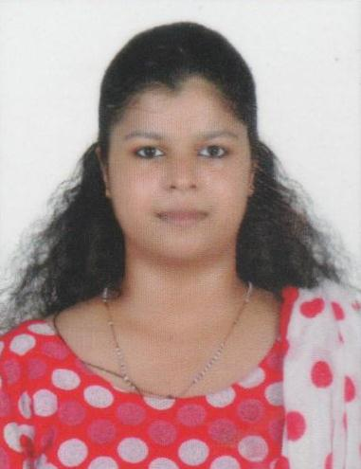 | 2 | Maria Geethu | baqu9022@student.alberts.edu.in | 9747562057
4 | Arts /Programme  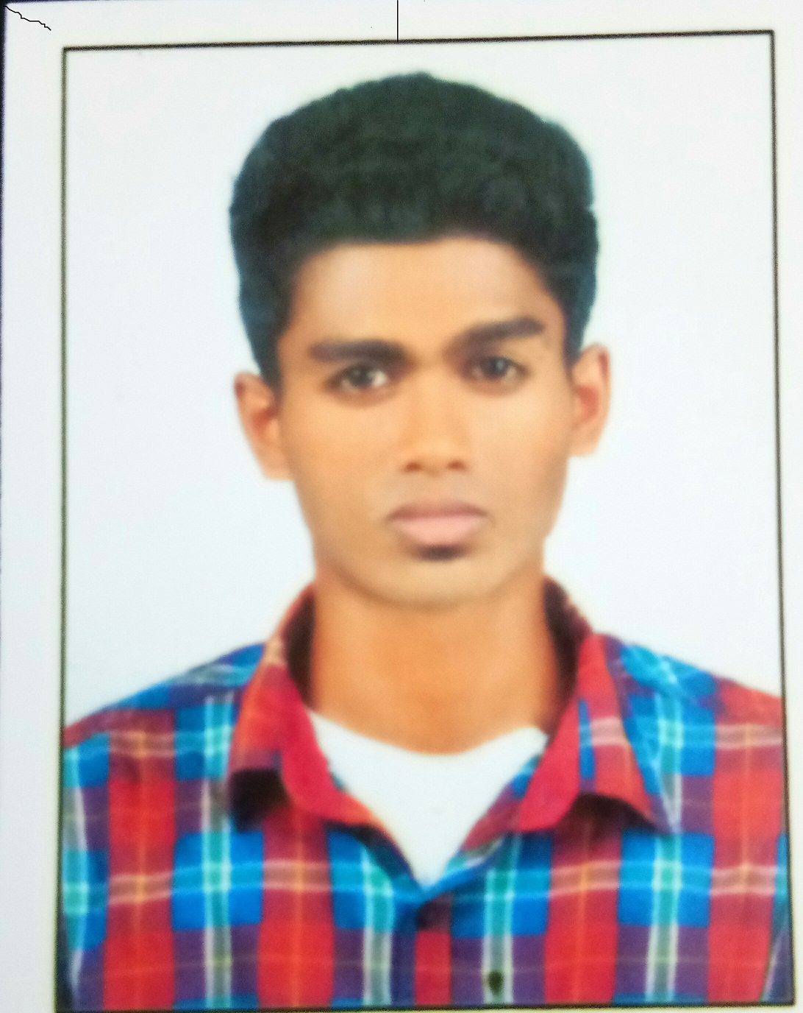 | 1 | Hrithik Rajesh | baqu9002@student.alberts.edu.in | 8138852248
 | 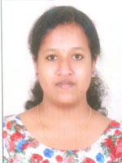 | 2 | Shifna P S | baqu9023@student.alberts.edu.in | 8592967580
5 | Sports  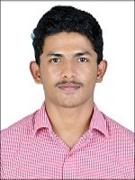 | 1 | Joel Roy Paul | baqu9001@student.alberts.edu.in | 9744974242
 | 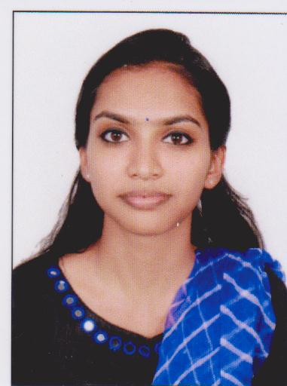 | 2 | Meghna Sebastian | baqu9011@student.alberts.edu.in | 9447795981
6 | Examination  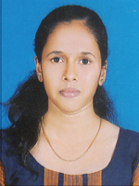 | 1 | Archana Baby | baqu9026@student.alberts.edu.in | 9539731333
 | 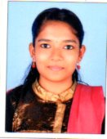 | 2 | Mary Sandra M J | baqu9003@student.alberts.edu.in | 6282457056
7 | Social Outreach  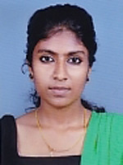 | 1 | Anjitha Bharathan | baqu9025@student.alberts.edu.in | 9207510132
 | 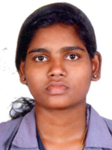 | 2 | Adithya V R | baqu9009@student.alberts.edu.in | 9567822616
8 | Placement- Career  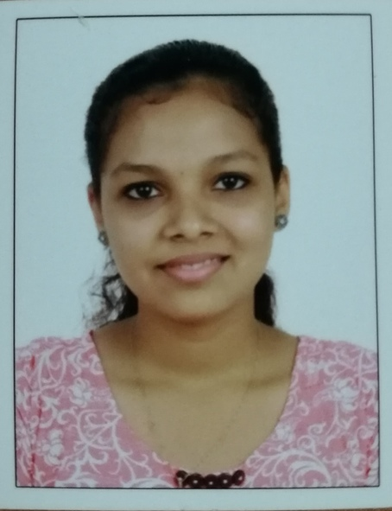 | 1 | Rainu Correya | baqu9016@student.alberts.edu.in | 9947854448
 | 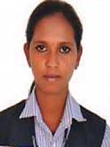 | 2 | Jayalakshmi V J | baqu9020@student.alberts.edu.in | 9744317335
9 | IEDC/IIC  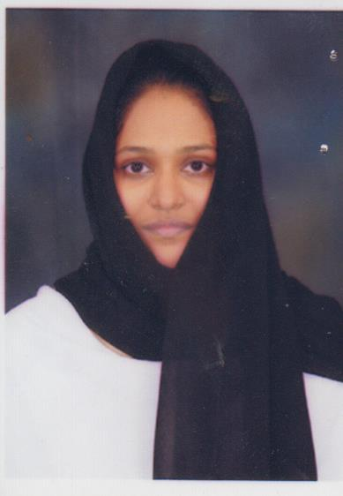 | 1 | Irfana P P | baqu9031@student.alberts.edu.in | 8281144693
 | 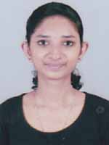 | 2 | Emily Xavier | baqu9013@student.alberts.edu.in | 9605036624
10 | e- Governance  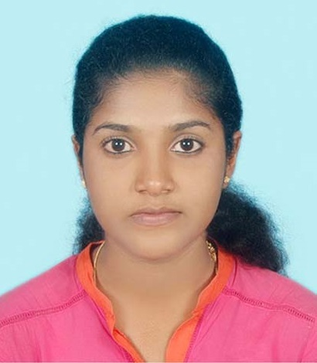 | 1 | Amala Swetha Renny | baqu9017@student.alberts.edu.in | 9074099784
 | 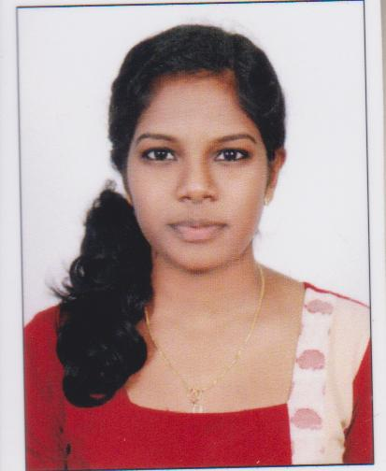 | 2 | Meera V T | baqu9010@student.alberts.edu.in | 7034293421
11 | Media  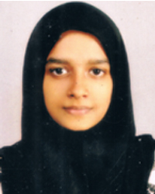 | 1 | Nadiya M A | baqu9005@student.alberts.edu.in | 9188023920
 | 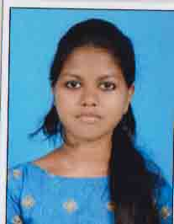 | 2 | Aarcha N Aravindan | baqu9028@student.alberts.edu.in | 9497770197
12 | Green  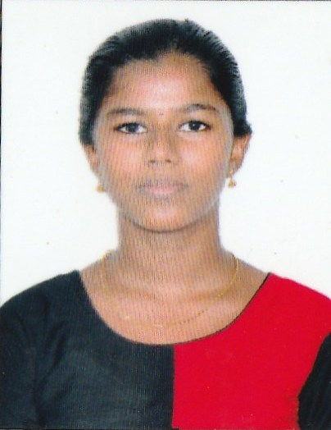 | 1 | Margarita Honey | baqu9015@student.alberts.edu.in | 9847159692
 | 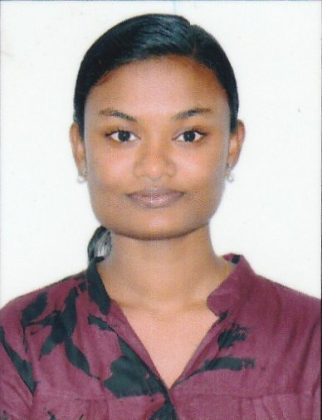 | 2 | Taniya Joseph | baqu9014@student.alberts.edu.in | 9562089819

