REPORT
BLOG AND WEBSITE DESIGNING
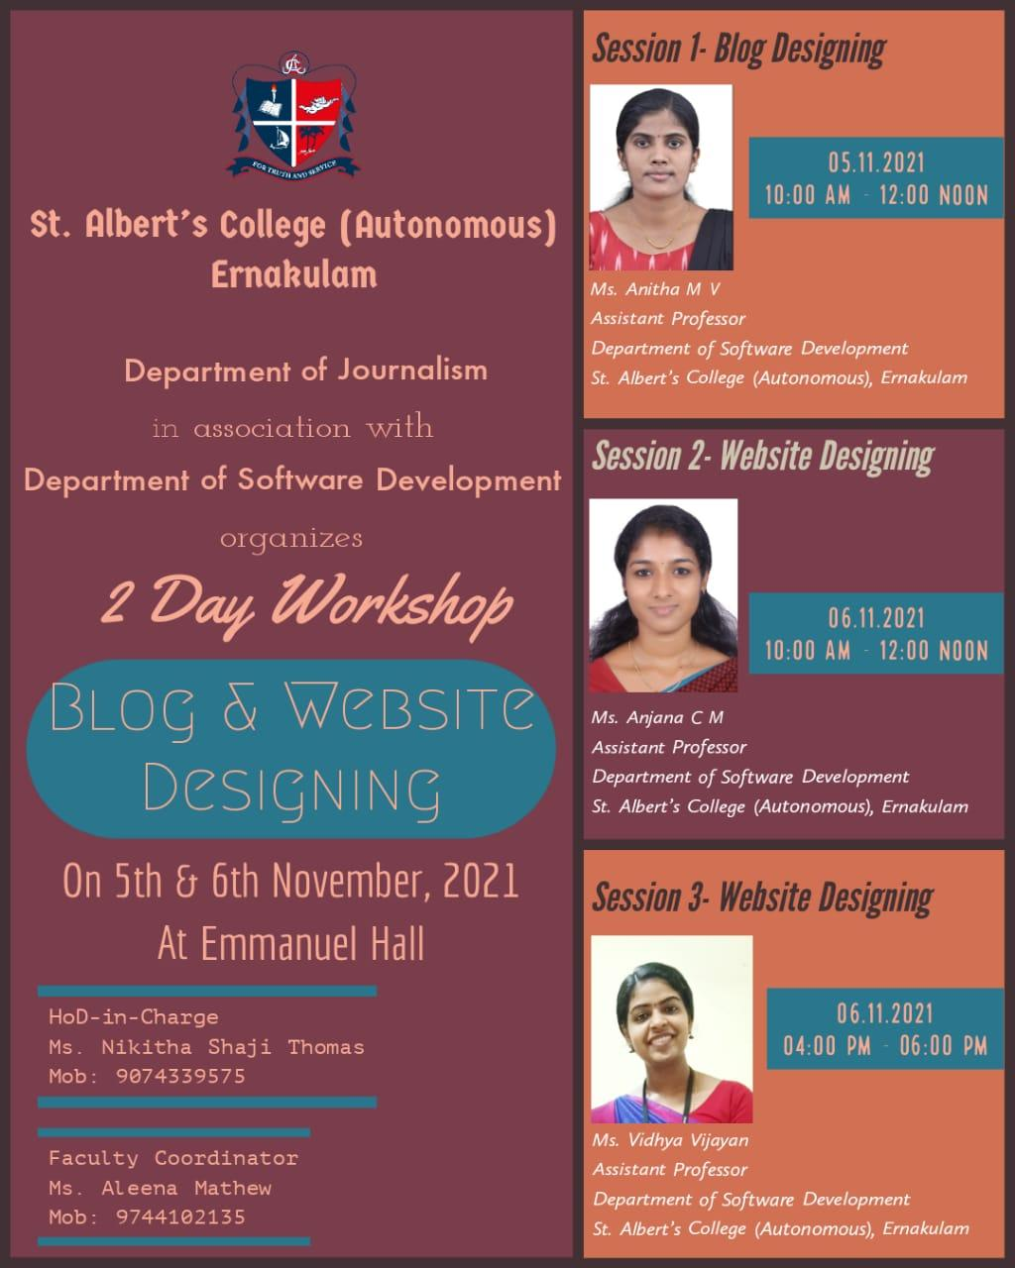

The department of Journalism in association with the Department of Software Development conducted a 2 day Workshop on Blog and Website Designing on 5th and 6th November 2021 at Emmanuel Hall. The programme began with a welcome speech by Assistant Prof.Krishnendu R, Department of Journalism and Mass Communication. There were Three sessions in the Workshop. The first session was ‘ Blog Designing’, taken by Assistant Prof Anitha M V, Department of Software Development on 05-11-2021 from 10 am to 12pm.The second session was on ‘Website Designing’, lead by Assistant Prof.Anjana C M, Department of Software Development on 06-11-2021 from 10 am to 12 pm. The last session was also about ‘Website Designing’ which was carried out by Assistant Prof.Vidhya Vijayan, Department of Software Development on 06-11-2021 from 4pm to 6 pm . The programme ended with a Vote of Thanks, given by Evelin Elsa Francis, II BA English Triple Main student

