Yuletide 2020

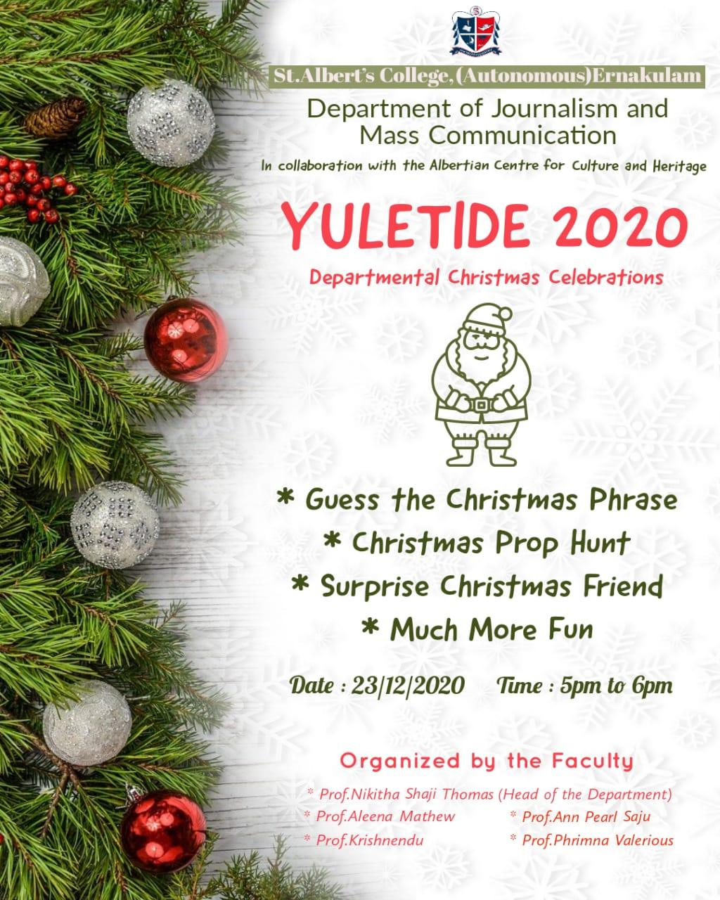Faculty members of the Department of Journalism and Mass Communication, in collaboration with Albertian Center for Culture and Heritage, organized YULETIDE 2020: Departmental Christmas Celebrations on 23rd December 2020 from 5:00 PM to 6:00 PM, via Google Meet. The programme had games such as Guess the Christmas Phrase and Christmas Prop Hunt. Each student was assigned a Surprise Christmas Friend, by Prof. Nikitha Shaji Thomas, the Head of the Department, after picking a lot. The students were informed, well in advance, to bring a self-made Christmas card when they attended the session. They were then asked to write the name of the Christmas friend they got on the card they made and post it in the class group. Prof. Nikitha Shaji Thomas, the Head of the Department, declared “Yuletide” as the official title of the Department Christmas Celebration. The programme wound up at 6:00 PM with a Christmas message by Prof. Nikitha Shaji Thomas.

