Swaranjali Music Festival

Journalism department of St. Albert's College (Autonomous) organised an eventful music programme named Swaranjali to celebrate World Music Day on June 21, 2021 at 12 p. m. Ms. Chandni, playback singer (of Mazhavil Manorama Indian-Voice fame ) and actor inaugurated the event which saw participation of singers from various colleges and walks of life. Akhila Johny of B.A. Triple Main sang the prayer song and student coordinators Angela and Aiswarya handled the emceeing. The HoD, Nikitha Shaji Thomas welcomed the virtual gathering and ‘a spontaneous overflow’ of music began. Dr. Vineeth KM- Govt. College, Tripunithura, Ms. Mary Sruthy Melbin- St Teresa's College, Dr. Rosalind Gonzaga-Vice principal of our college and Prof. Preethi Francis- Fisheries and Aquaculture were among the many singers who graced the virtual occasion. Other teachers of the college, students, parents and children sang for the event and made it a memorable affair. The organisers shared their appreciation for all who got together even during this grim time of Covid and their satisfaction for being able to conduct the event. Ms. Eveline of B.A. Triple Main said the vote of thanks.

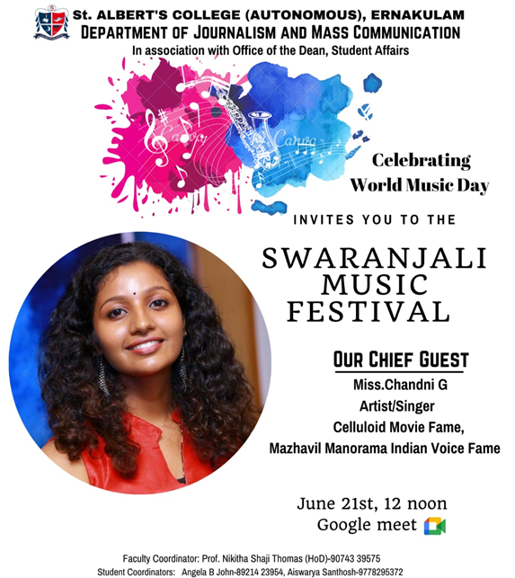

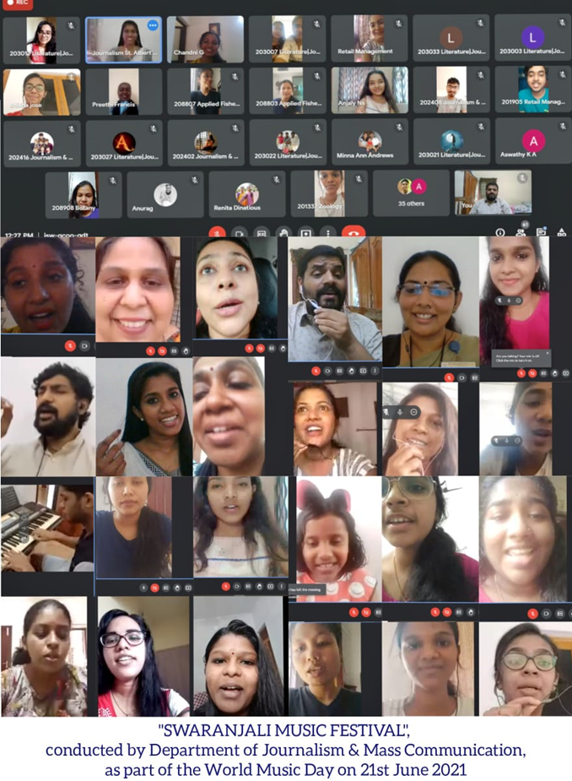
v

