- Intercollegiate Cartoon Competition

Department of Journalism and Mass Communication of St. Albert’s college (Autonomous), Ernakulam marked World Day Against Child labour on 11th June 2021 by organising an Intercollegiate Cartoon Competition. The themes of the competition were “Give them Care, Not Labour” and “Act Now, End child Labour” respectively. The posters for the same were circulated a week early among different colleges in and around Kochi. In the cartoon competition, Prof. Abinash John Peter, HoD-in-Charge of the department of Space Science, selected Vishnupriya V(Assumption College, Changanassery), Meril Treesa(St. Albert’s College) and Athira Bharathan (Govt.College, Peringome) for first, second and third prize respectively. The winners were give e-certificate as our token of appreciation. Under the guidance of Nikitha Shaji Thomas, HoD, Asst. Prof. Aleena Mathew, Asst. Prof. Krishnendu and Asst. Prof. Minna Ann Andrews coordinated the above events and saw to its effective conclusion. The student coordinators Amala Philomina of B.A. Triple Main and Sradha Santosh of B.Voc Journalism and Mass Communication also were part of the team.
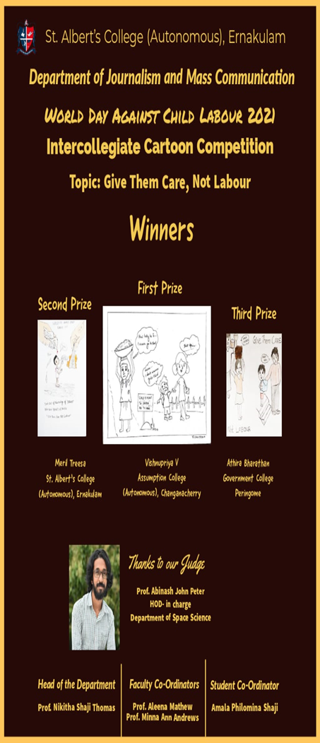
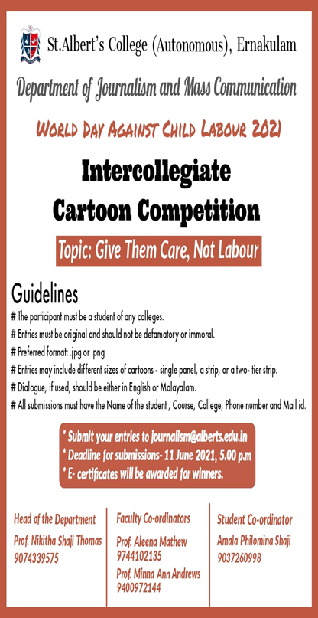

2 Intercollegiate short video competition
Department of Journalism and Mass Communication of St. Albert’s college (Autonomous), Ernakulam marked World Day Against Child labour on 11th June 2021 by organising an Short-Video Competition. The themes of the competition were “Give them Care, Not Labour” and “Act Now, End child Labour” respectively. The posters for the same were circulated a week early among different colleges in and around Kochi. Of the 6 entries received, Dr. Nisha Thomji Varghese, HoD of the Department of English selected Rithukumar of B.Sc. Industrial Fisheries as the winner in the short-video competition. The winners were given e-certificate as our token of appreciation. Under the guidance of Nikitha Shaji Thomas, HoD, Asst. Prof. Aleena Mathew, Asst. Prof. Krishnendu and Asst. Prof. Minna Ann Andrews coordinated the above events and saw to its effective conclusion. The student coordinators Amala Philomina of B.A. Triple Main and Sradha Santosh of B.Voc Journalism and Mass Communication also were part of the team.

