SCHOLA BREVIS-2020
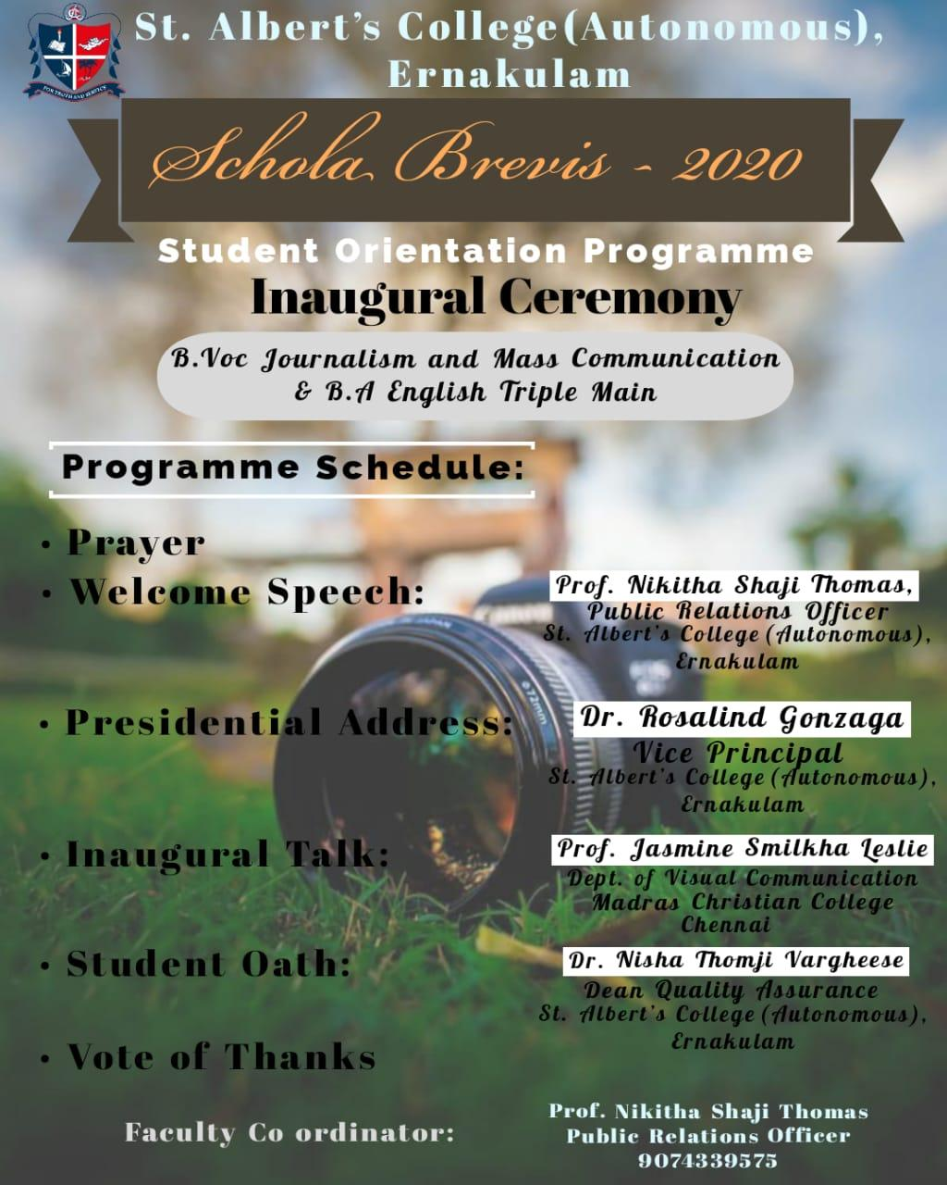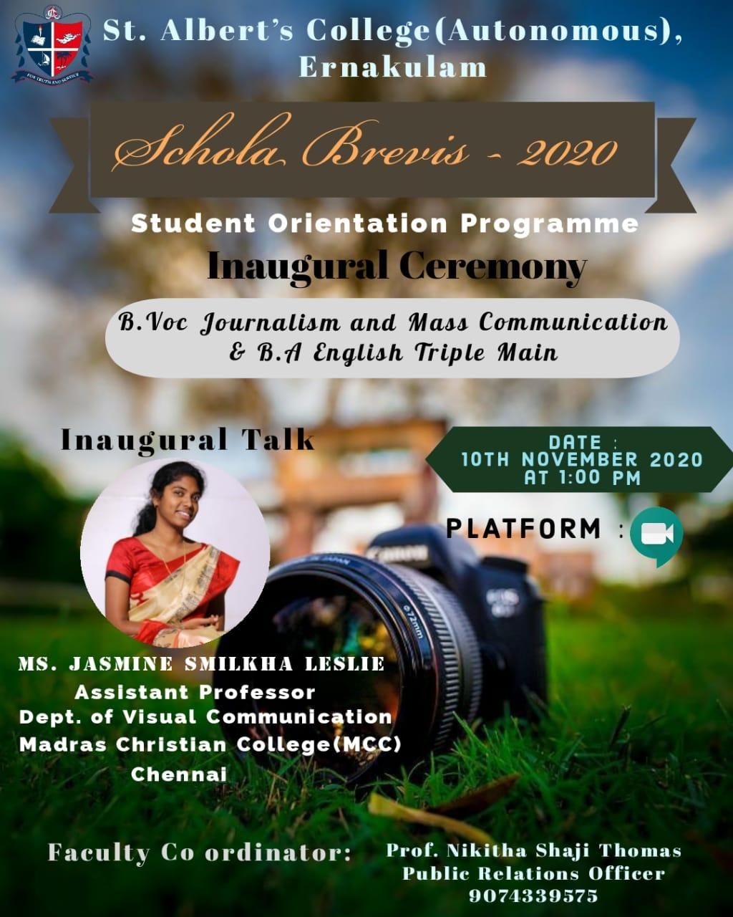Department of B.Voc Journalism and Mass Communication along with Department of B.A. English (Triple Main) of St. Albert’s College (Autonomous), Ernakulam, conducted a four day Student Orientation Programme for their first batch of students, from 10th November 2020 to 13th November 2020, via Google Meet. It was co-ordinated by Prof. Nikitha Shaji Thomas, the Public Relations Officer from the Department of B.Voc Journalism and Mass Communication.
The Inaugural Ceremony commenced with a prayer at 1:00 PM, followed by the welcome speech by Prof. Nikitha Shaji Thomas. The Presidential Address was delivered by Dr. Rosalind Gonzaga, Vice Principal of St. Albert’s College (Autonomous), Ernakulam. Ms. Jasmine Smilka Leslie, Assistant Professor from the Department of Visual Communication, Mardras Christian College (MCC), Chennai, gave a 30 minutes session for the students regarding the scope and job opportunities of the course Journalism and Mass Communication and then officially inaugurated the orientation programme. Dr. Nisha Thomji Varghese, Dean of Quality

Assurance, St. Albert’s College (Autonomous), Ernakulam, administered the student oath and the student representative Kavya Binu repeated the oath after her. The session concluded at 1:45 PM with the Vote of Thanks.
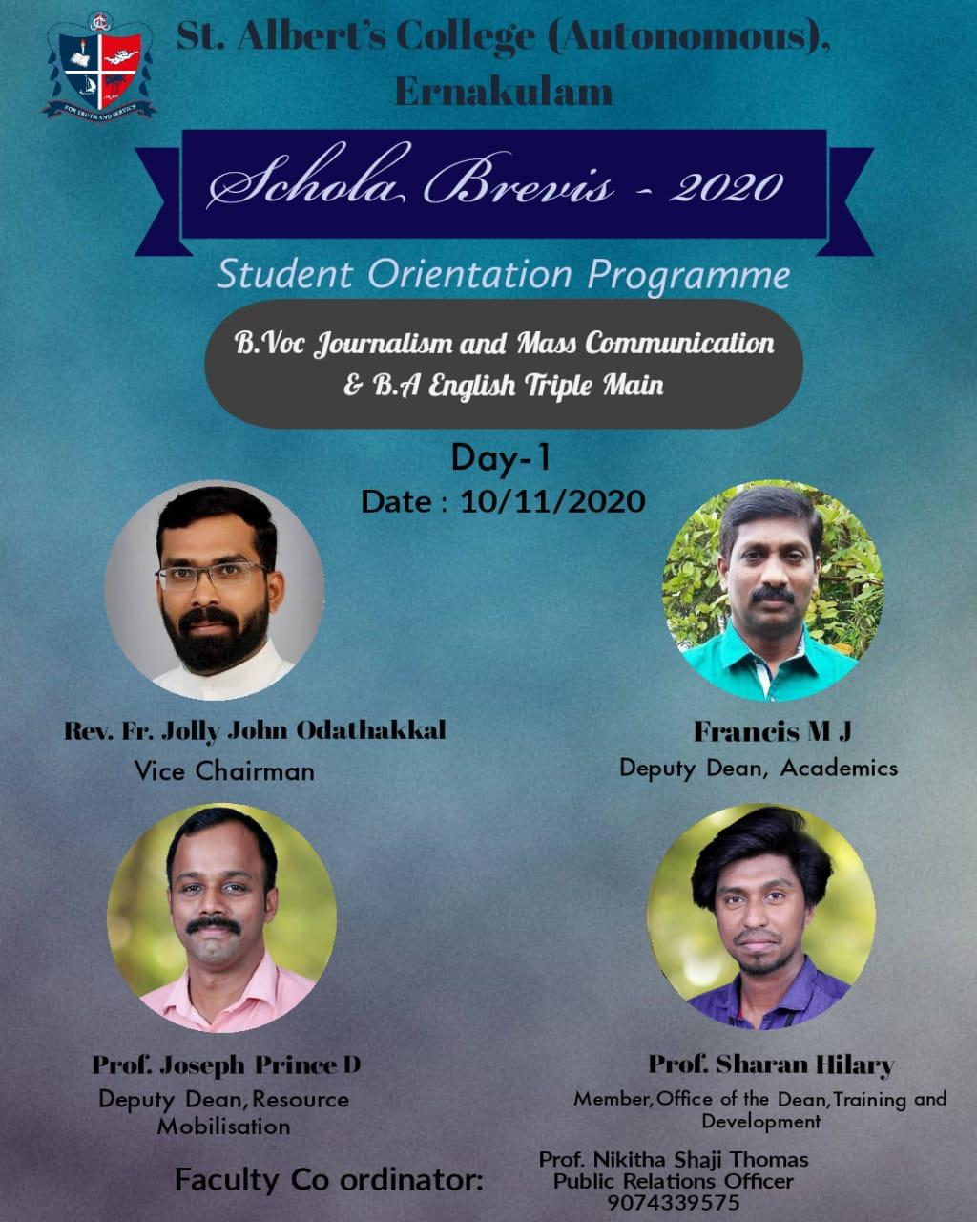The official Inaugural Ceremony was followed up with a session by Rev. Fr. Jolly John Odathakkal, Vice Chairman of St. Albert’s College (Autonomous), Ernakulam. Father addressed the students about the legacy of the college and the role it plays in moulding and shaping the future of each student who is now an Albertian. Next, Prof. Francis M.J, Deputy Dean of Academics, St. Albert’s College (Autonomous), Ernakulam, talked about the nuances and relevance of the Journalism and Mass Communication courses. Subsequently, Prof. Sharan Hilary, Member of the Office of Dean, Training and Development, introduced the students to the extra-curricular activities that the college offers. The session for the first day was concluded at 4 PM with a session by Prof. Joseph Prince D., Deputy Dean of Resource mobilization.

Second day of the student orientation programme started at 12 PM with a session by Dr. Anisha.S., Deputy Dean of Research of St. Albert’s College (Autonomous), Ernakulam, where she briefed the students about the different prospects of research. This was carried on with a session by Prof. Neeraja T.S, Member of the Office of the Controller of Examinations. She gave a detailed awareness to the students regarding the examinations and the marking schemes. Thereafter, Prof. Lashmi G, IIC Committee Member of the Dean and Management talked about the business and entrepreneurship opportunities that the college provides and encouraged the students to come up with innovative and creative initiatives. 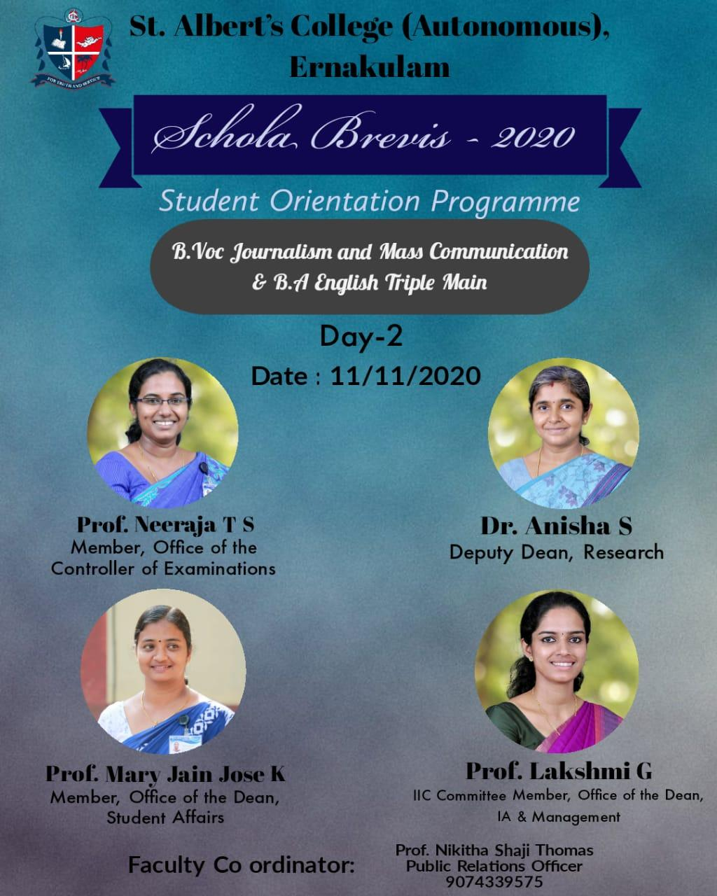

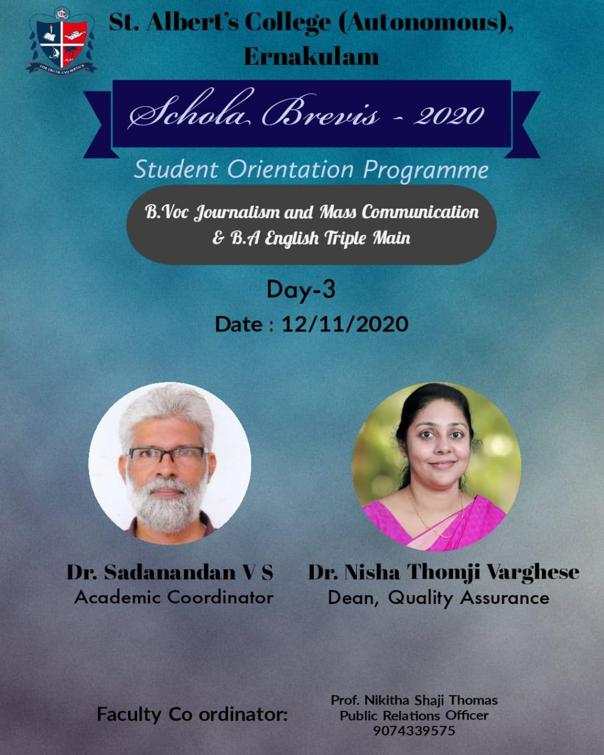On the third day of the student orientation programme, held on 12th November 2020, Dr.Sadanandan V.S, Academic Coordinator of St. Albert’s College (Autonomous), Ernakulam, addressed the students about thee rules and regulations of the college. The second session for the day was led by Dr.Nisha Thomji Varghese, Dean of Quality Assurance of St. Albert’s College (Autonomous), Ernakulam. She introduced the students to different facets of research.

On 13th November 2020, the final day of the student orientation programme, Mr Jerin Joy, an industrial expert, who works as a senior reporter at Malayala Manorama, Kollam, briefed the students on the job description and the risks involved in the field of Journalism. Ms. Gladious Guna Ranjini familiarised the students about the wide opportunities awaiting them after the successful completion of their courses. In the last session, the Alumni of the college, Ms Devika V, Asst. Professor, St. Albert’s College (Autonomous), Ernakulam [ M.A English 2019, passout] and Ms Sharon Rodrigues, Content Writer, Times Groups of Education, UAE [ M.A English 2019, passout] shared their memories at St. Albert’s college with the students. The session ended at 4 PM.
